|  |  |
| --- | --- |
| Name | Enayathulla A |
| Date | 03/01/2024 |
| Type | Daily Assignment |
| Topic | Creating Storage Account |

**Storage Account:**

* + Azure account contains all of our azure data objects like blobs, files, queues and tables. The storage account provides a unique namespace for our Azure Storage data that is accessible from anywhere in the world over HTTP or HTTPS.
  + It supports world wide hosting.
  + Storage account is must need for performing function executions and task execution.

**Data Lake:**

* + Azure Data Lake includes all the capabilities required to make it easy for developers, data scientists, and analysts to store data of any size, shape, and speed, and do all types of processing and analytics across platforms and languages.
  + If we created storage account means we can access the files from any where into azure for computation process and also that generated URL allow public also view that file through website.

**Creating Storage account:**

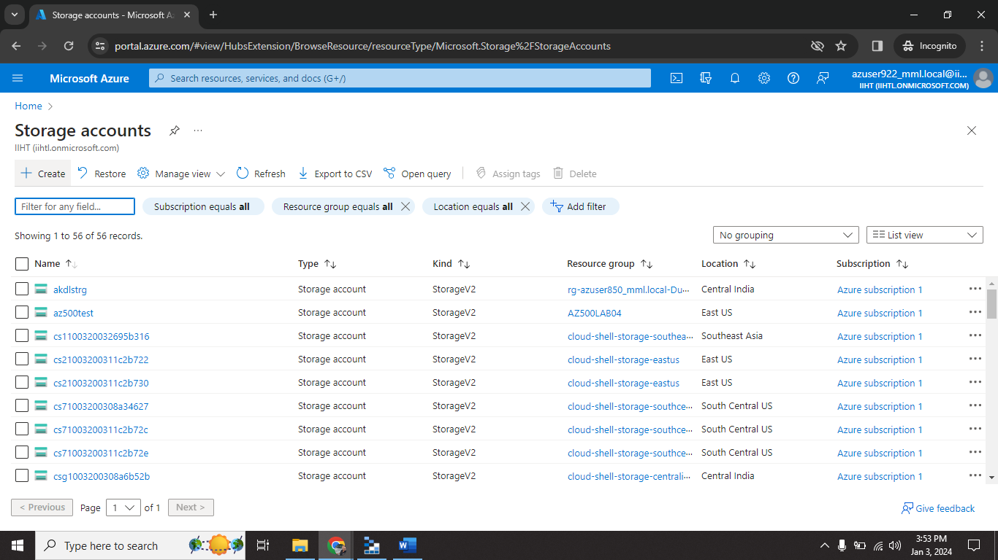

Step 1: search storage account in search bar.

Step2: click on create tab to create new storage account.

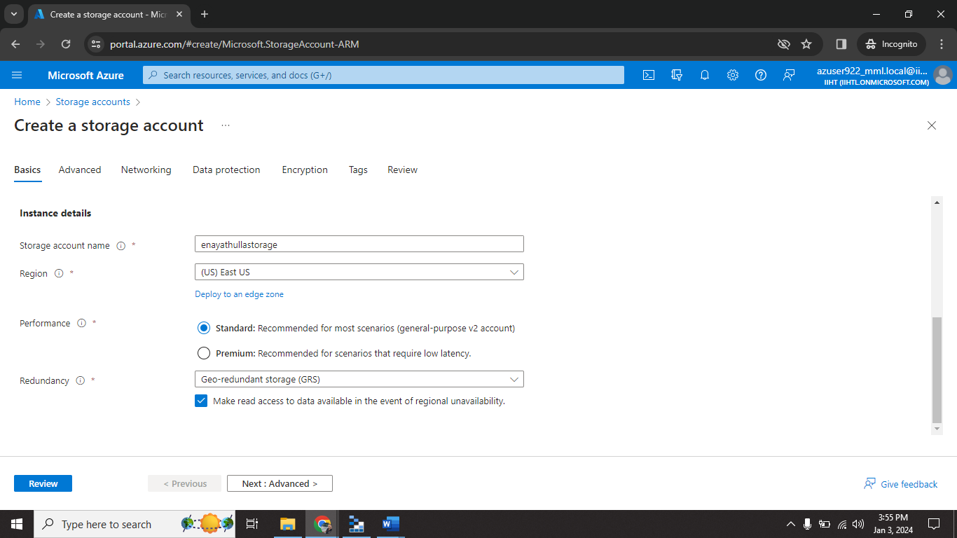

Step3: give storage account name.

Step4: select region for your convenience.

Step5: select standard performance.

Step6: click on advance.

Step7: in advance select hierarchy check box.

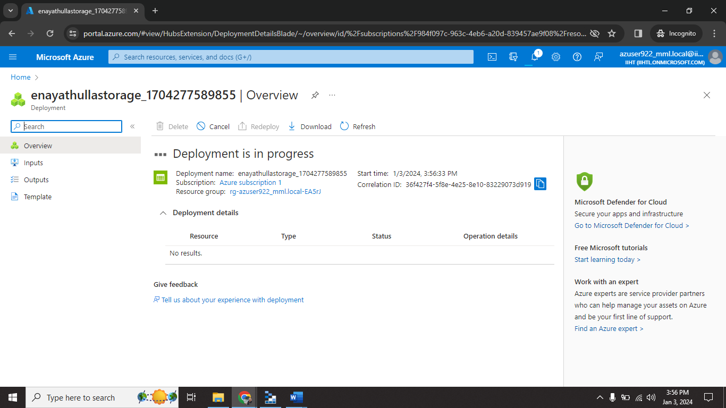

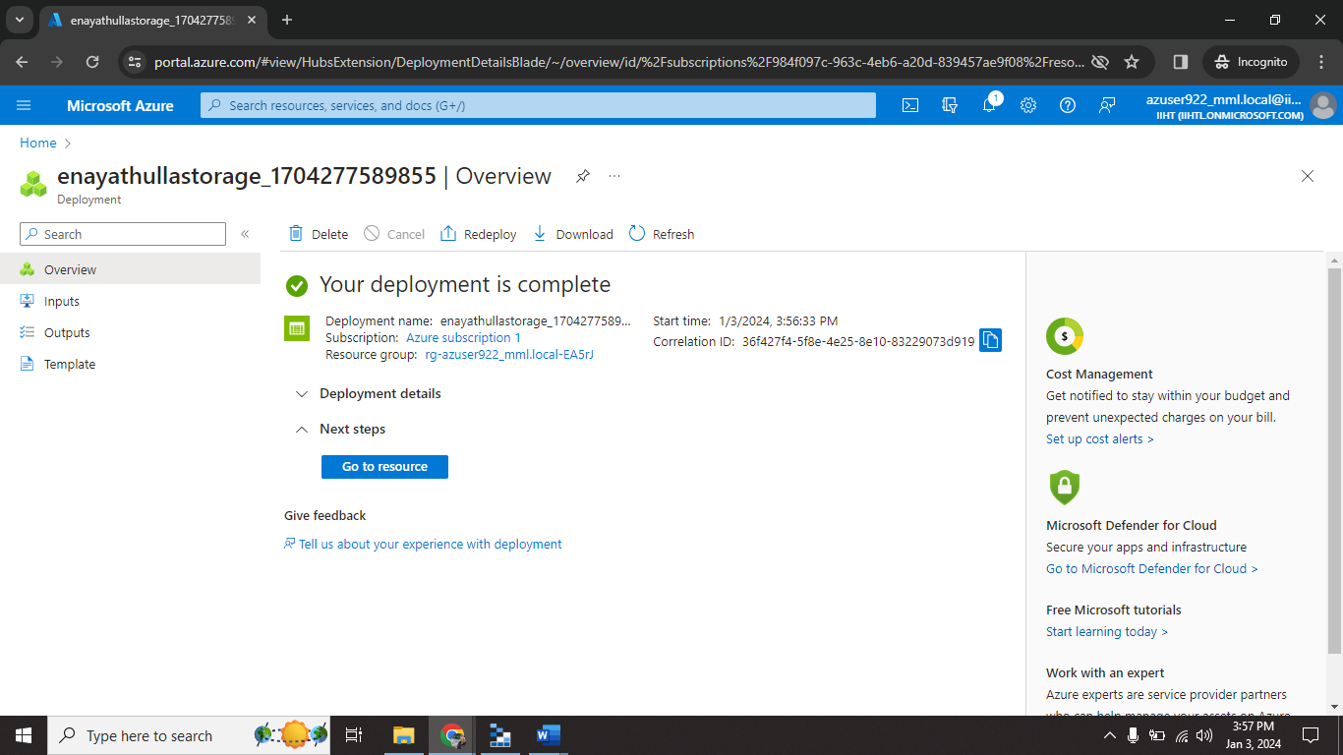

Storage account successfully created on my resource group.

**Combine storage account with storage explorer:**

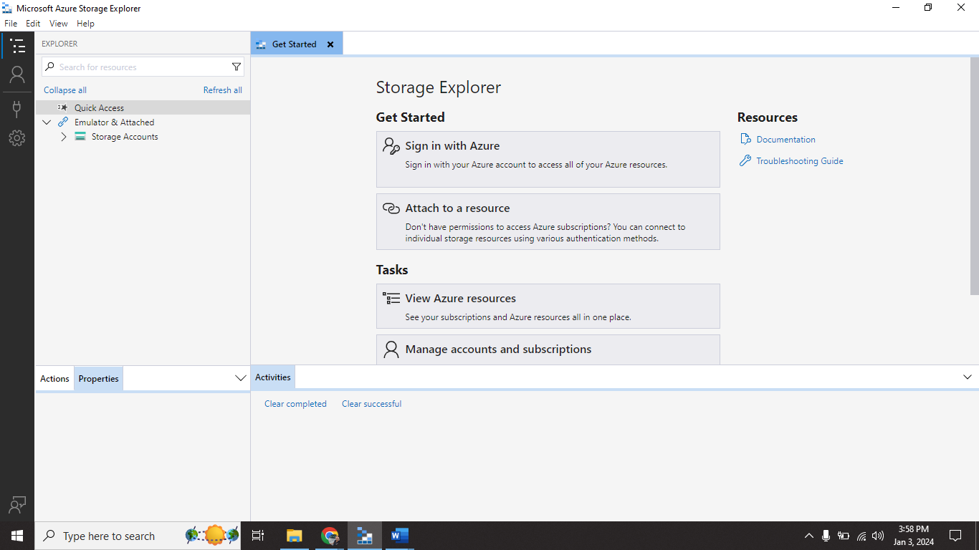

Step8: Open storage explorer.

Step9: click on sign in with azure.

Step10: redirect to browser for login.

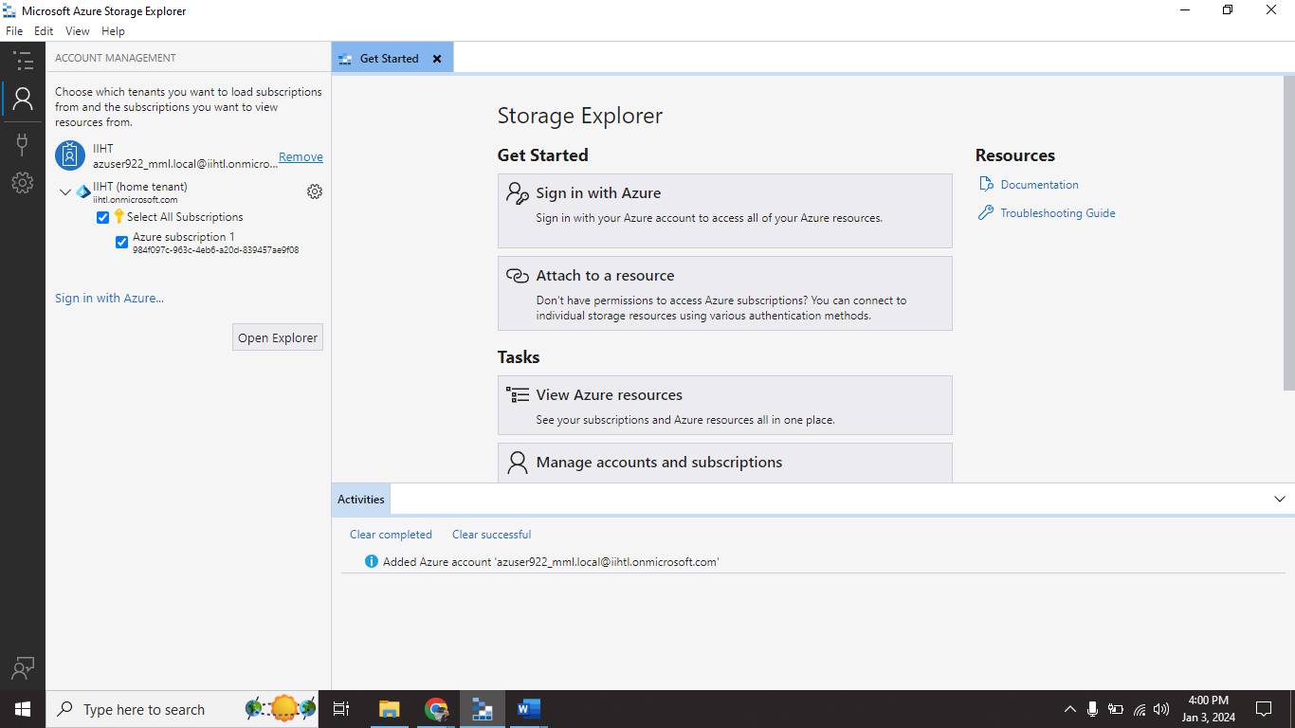

Step11: after successful login you select storage account option.

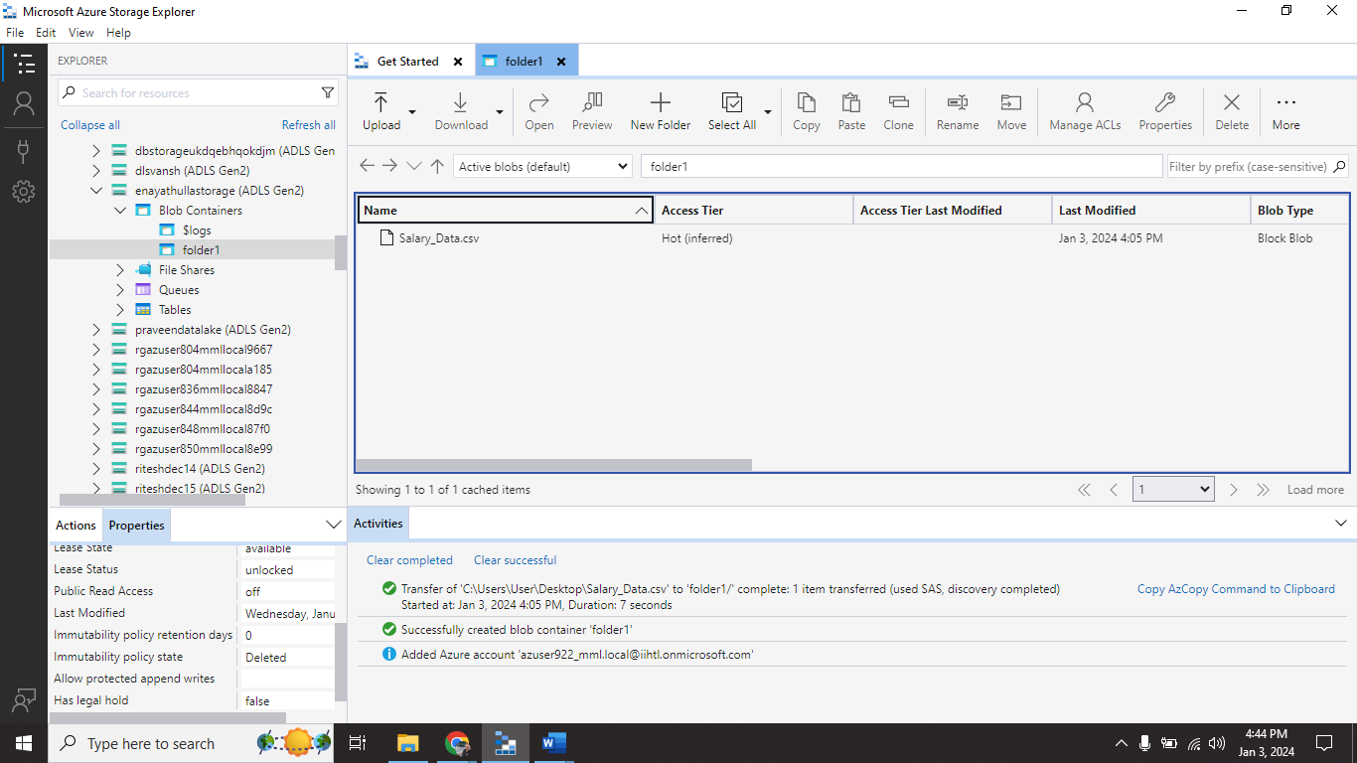

Step12: select your storage account and go to Blob Containers.

Step13: right click on that create new container folder1.

Step14: click on upload and upload local files.

Now you will see your local file into azure storage account.

**Delete storage account:**

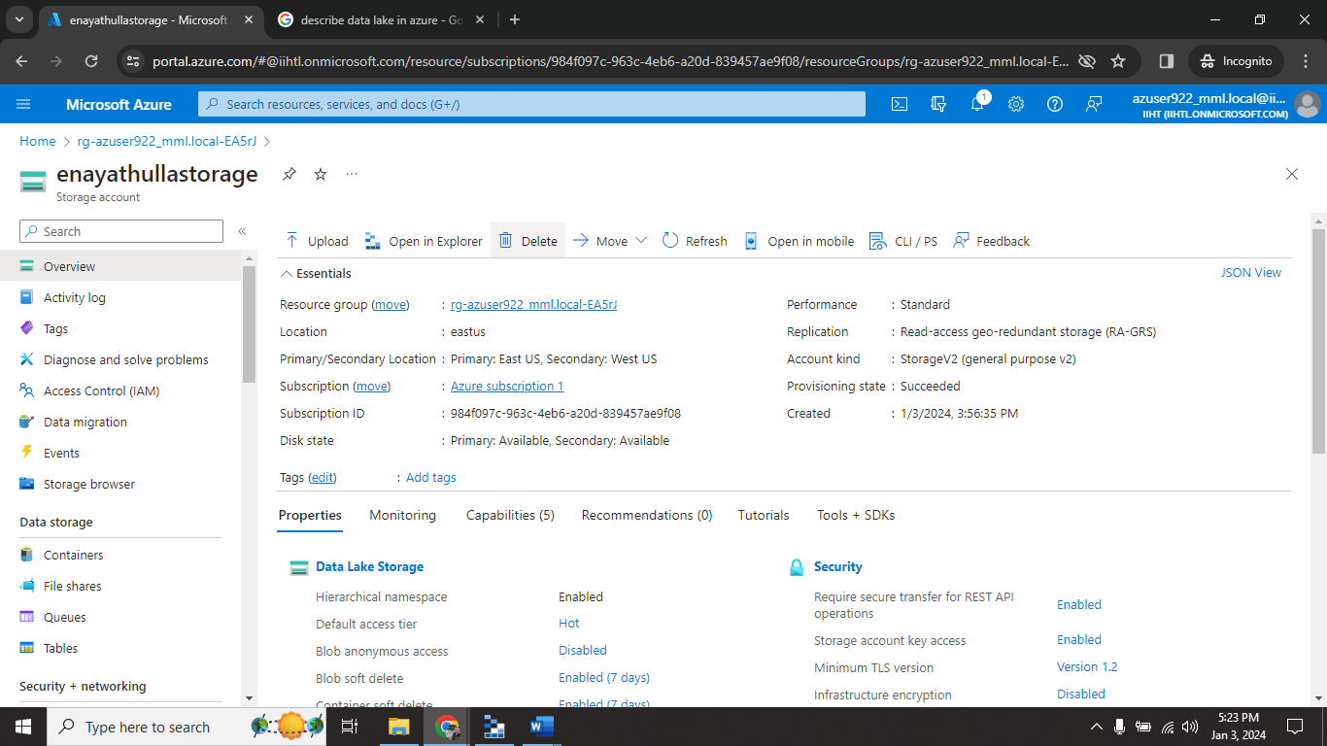

Step15: go to storage account page.

Step16: click on delete.

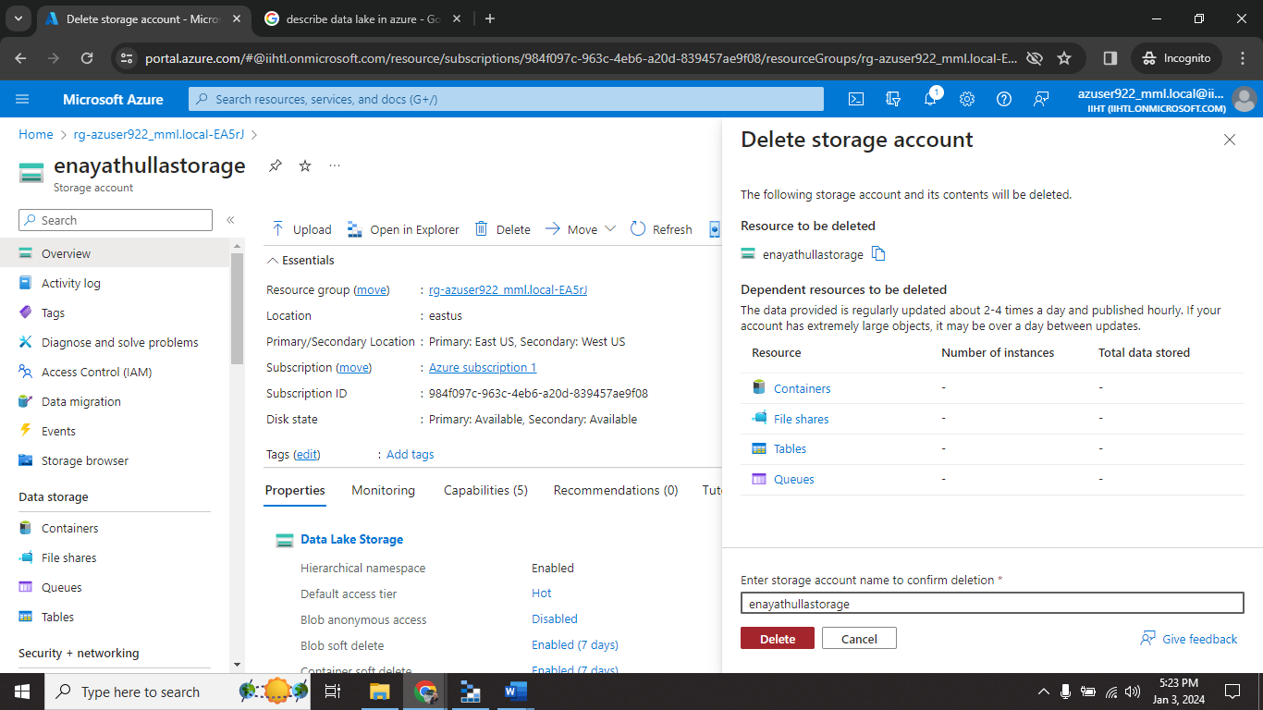

Step17: enter storage account name.

Step18: click on delete.